Eddie Carter-Cook
Ms. Snyder
Capstone-Final Draft
17 April 2019

Eddie Carter-Cook
Ms.Snyder
Capstone-Final Draft
17 April 2019
The Life of a Physical Therapist
Imagine an athlete playing a professional sport and being injured with no help or motivation to get back on his or her feet; then, a knight in shining appears and propels this athlete back into prime playing form. If guaranteed a chance to become healthy both mentally and physically, all athletes would take this path and reach out to a physical therapist. Physical therapy entails “care that aims to ease pain and help you function, move and live better” (Physical Therapy). They spend countless hours trying to improve the mobility of a patient. Physical Therapists not only help athletes get back to where they once were, but they also try to prevent the situation from occurring again. It is a physical therapists job to never give up on their client; it is their goal and mission to get them back to where they once were so that they can succeed. The benefits of physical therapy exercise are becoming healthy, helping reduce pain, and preventing surgery.
Physical therapy is no ordinary walk in the park; there is actually a lot that comes with being a licensed physical therapist. For example, physical therapists deal with a lot of different people whether the patients are small or tall, big or skinny, they work with them. “Physical Therapy Exercise is a controlled physical stress that is applied to the body to help improve the strength, mobility, and range of motion” (Sears). There are different methods and treatments to understand and each patient will always have their own unique plan. The ultimate goal is getting the patient as close to one hundred percent healthy as possible. Physical Therapists try to go above and beyond to eliminate as much pain as possible and improve mobility for as long as needed. Most patients believe that physical therapy is only for the elderly or impaired and that’s not the case. Studies show that a high percentage of teens between the age of 18-25 begin to develop a great amount of back pain which could carry on unto the patients elderly days (Wang) . A lot of teens tend to feel embarrassed about seeing a physical therapist so they just live on with the pain and suffer through it in their elderly days.
Physical therapists have patients that rely on them when they are impaired or disabled. Many patients are told they will be paralyzed for life or can never run again or walk but as a physical therapist, it is their mission to prove that physician wrong. Although “Physical therapist won’t take the place of your doctors but they will work with your physician” (Physical Therapy.) there is a mission to help better improve the health of the patient. There are many different everyday problems that are not even thought about like properly standing up from a chair; it is actually difficult how it is to be properly done because it has been done incorrectly for so long. Even picking up a box could cause many problems because a large number of people use their back and not much of their legs to pick the box up and think nothing of it. Wondering why they have so many back and knee pains when they reach a certain old age, is something that is easily avoidable, but a patient must be open and willing to suggestions from an expert such as a physical therapist.
A patient will be examined to access the severity of the pain and what different exercises that need to happen to eliminate the pain. They then begin to ask what goals a patient trying to receive with this program.”Most physical therapy programs start off with passive treatment but slowly progress to active treatment” (Marovino) In other words, each patient will receive a paper full of different types of exercise, for example, sit down and stand up ten times without the use of
your hands or 15 squats it depends on how severe your injury is. The physical therapist would then ask that they please follow these daily work out as if it was a homework assignment.It could be as little as asking them to touch their toes ten times or doing some squats around the house.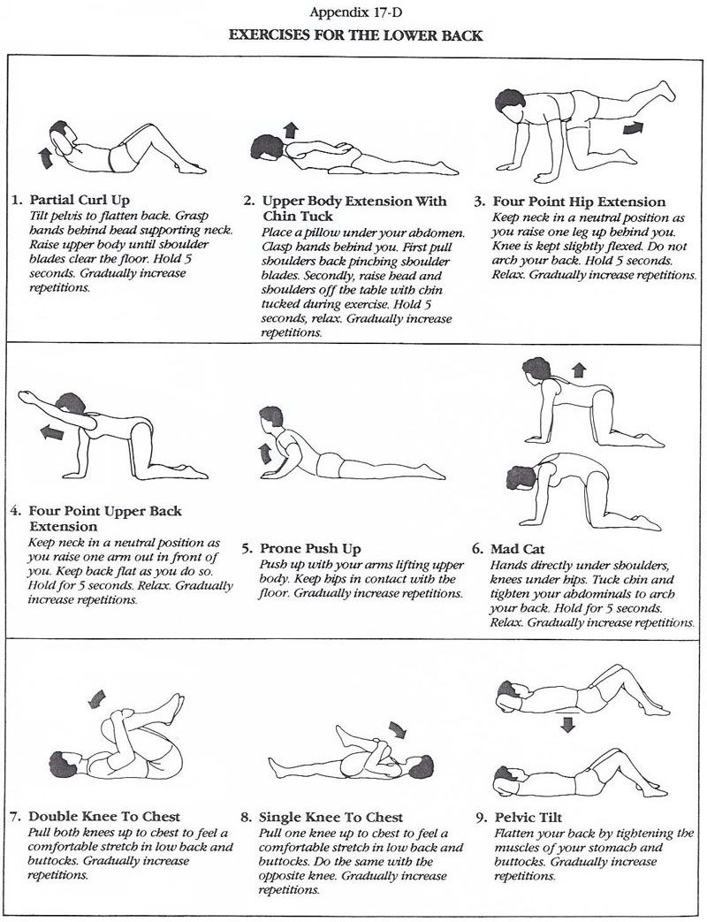
In conclusion, the life of a physical therapist can be stressful, but to see healthy patients and their smiles after completing the program is all the reward that is needed. Just watching the patient's progress from day one until the end can really put a smile on someone's face. Examining the patient while watching their growth and changing that ‘’I CAN’T’’ to ‘’I CAN’’ also provides internal satisfaction for a therapist whose one goal is to help these patients achieve all their goals. Like a physical therapist stated, “Physical therapists take care of patients in all phases of healing” (Minnis.) No matter what the severity of the situation is or if there ever was a time period, a physical therapist would never leave a patient to struggle. They will always be there to assist. So if ever impaired or if mobility is taken away, physical therapists are the people to go to.

Works Cited
Fritz, Julie M., and Shannon N. Clifford. “Low Back Pain in Adolescents: A Comparison
of Clinical Outcomes in Sports Participants and Nonparticipants.” Journal of Athletic Training (National Athletic Trainers’ Association), vol. 45, no. 1, Jan. 2010, pp. 61–66. EBSCOhost, doi:10.4085/1062-6050-45.1.61.
Gregory Minnis, DPT. "Physical Therapy: Who Can Benefit And How Can It Help?". Medical
News Today, 2019, https://www.medicalnewstoday.com/articles/160645.php.
“Physical therapist take care of patients in all phases of healing”
Johansson, Ewa‐Lena, et al. “Physical Therapy Treatment of Impaired Chest
Mobility in Patients with Airway Sensory Hyperreactivity.” Physiotherapy Research International, vol. 22, no. 2, Apr. 2017, p. n/a-N.PAG. EBSCOhost, doi:10.1002/pri.1658.
Marovino, Tiziano. "Physical Therapy And Rehabilitation". Practical Pain Management,
2019, https://www.practicalpainmanagement.com/patient/treatments/physical-therapy-rehabilitation/physical-therapy-rehabilitation. Accessed 25 Mar 2019.
“Physical Therapy Exercises, Manual Therapy, Hydrotherapy. How It Works.” WebMD,
WebMD, www.webmd.com/pain-management/what-is-physical-therapy#1.
Sears, Brett. "8 Common Ways Physical Therapists Will Treat Your Injury". Verywell Health,
2019,
https://www.verywellhealth.com/physical-therapy-treatments-and-modalities-2696683. Accessed 8 Apr 2019.
“Top 10 Key Benefits of Physical Therapy.” 6 Different Types of Physical Therapy |
Movement for Life, Weber Rebeccah,
www.movementforlife.com/blog/top-5-key-benefits-of-physical-therapy.php.

Wáng, Yì Xiáng J, et al. “Increased Low Back Pain Prevalence in Females than in Males
after Menopause Age: Evidences Based on Synthetic Literature Review.” Quantitative Imaging in Medicine and Surgery, AME Publishing Company, Apr. 2016, www.ncbi.nlm.nih.gov/pmc/articles/PMC4858456/.

